**Yield Farming Strategy with Polygon on Aave**

What is Polygon?

[Polygon](https://polygon.technology/) (previously Matic Network) is aiming to be a network of blockchains. It is also a scaling solution for Ethereum. Through its Plasma technology, Polygon processes transactions off the main Ethereum chain before finalizing them on the Ethereum chain. By processing off-chain, Polygon can have much higher throughput, resulting in faster and cheaper transactions. Polygon is only one solution to the Ethereum scaling problem but has received good traction so far with Aave, Curve and SushiSwap all offering their services on Polygon.

## What is Aave?

[Aave](https://aave.com/) is a DeFi protocol that allows users to deposit and borrow cryptocurrency. Depositors provide liquidity and get rewarded with passive income. Borrowers can borrow cryptocurrency and pay an interest rate on it. To borrow, users must have deposited assets to the Aave protocol (collateral). At first, when I discovered Aave I wasn’t quite sure why someone would take a loan out against their assets instead of just selling the asset. After a bit of thinking and using, it made sense. Rather than selling an asset to fund your needs, you can keep that asset (thereby participating in any upside) while getting access to the liquidity you need.

## What is DeFi?

Decentralized finance is a blockchain-based form of finance that does not rely on central financial intermediaries such as brokerages, exchanges, or banks to offer traditional financial instruments, and instead utilizes smart contracts on blockchains, the most common being Ethereum.

## What is Aave?

[Aave](https://aave.com/) is a DeFi protocol that allows users to deposit and borrow cryptocurrency. Depositors provide liquidity and get rewarded with passive income. Borrowers can borrow cryptocurrency and pay an interest rate on it. To borrow, users must have deposited assets to the Aave protocol (collateral). At first, when I discovered Aave I wasn’t quite sure why someone would take a loan out against their assets instead of just selling the asset. After a bit of thinking and using, it made sense. Rather than selling an asset to fund your needs, you can keep that asset (thereby participating in any upside) while getting access to the liquidity you need.

## What is Yield Farming?

Yield farming is the practice of moving funds from one DeFi protocol to another to maximize yield. Some DeFi protocols like [yearn](https://yearn.finance/vaults) automatically move your funds between protocols to maximize gains. Yield farming is the DeFi equivalent of switching bank accounts to receive more interest, just on a bigger scale at a higher speed. Yield farming as a practice has been prevalent on the Ethereum chain for a while, but due to the high gas fees I never tried it. With Polygon (and Arbitrum/Optimism coming soon) the fees are minuscule and yield farming is possible with as little as $100.

Liquidity mining is a component of yield farming. Liquidity mining involves receiving a token in addition to the regular yield. Networks and DeFi apps provide these tokens as an incentive to provide liquidity to the system. Polygon is providing its native token (MATIC) to users who interact with various protocols, including Aave.

## Polygon Network Access

To interact with the Polygon chain, you need to add the address manually to your wallet (I use [MetaMask](https://metamask.io/)). To add the Polygon network, follow the below steps.

* Select the dropdown that currently displays “Etherium Mainnet”



* Click “Custom RPC”



* Enter in the following settings
  + **Network Name:**Matic Mainnet
  + **New RPC URL:**<https://rpc-mainnet.maticvigil.com/> or [https://rpc-mainnet.matic.network](https://rpc-mainnet.matic.network/)
  + **ChainID:**137
  + **Symbol:**MATIC
  + **Block Explorer URL:**[https://explorer.matic.network](https://explorer.matic.network/) or <https://explorer-mainnet.maticvigil.com/>
* Click Save

You can now select the Matic/Polygon network in your MetaMask Wallet.

## Moving Funds

The approach you take to funding your DeFi exploits on Polygon will depend on where your funds currently are. If you have your funds in your wallet on the Ethereum chain, you will need to bridge them over to the Polygon network, and can transfer funds from Ethereum to polygon network.

**Aave Strategy**

## Simple leverage - 14.5%

If you deposit 1000 USDC into Aave ($1000), you can borrow $750 worth of tokens ([75% loan to value for USDC](https://docs.aave.com/risk/asset-risk/risk-parameters)). If you were to borrow 750 USDC tokens and then deposit them back into USDC Aave, you can earn more rewards! The process of lending against the money you borrowed to increase yield is called leverage.

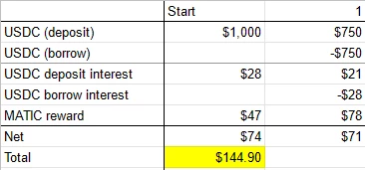

This is what the result would look like after 1 year (if the rates stayed constant), you'd owe some USDC from the loan but you'll more than make up for it with the 1750 USDC that you have deposited. You'll also make a decent amount of Matic rewards from the lending

Pros:

- Simple to understand and simple to implement

Cons:

- We can do better than this

## Recursive leverage - 32.8%

Astute readers may notice that in the previous strategy, since you deposit the borrowed USDC, you can borrow more USDC. You can repeat this cycle multiple times to increase your leverage. It's not really risky because if USDC goes up or down, both your borrowed and deposited amounts move at the same percentage.

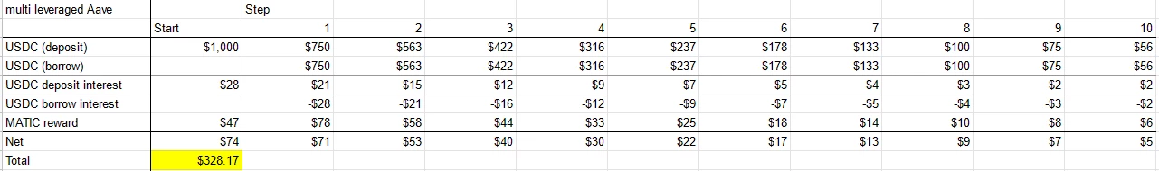

If you repeat the borrow->deposit->borrow process 10 times, you'd get 32.8% yield (much higher than the previous method), however, it is a bit of a pain to click borrow, then deposit, then click borrow again and you definitely run into declining returns later on since you can only borrow 75% of the previous amount borrowed.

**Pros:**

- No currency risk

**Cons:**

- Can be tedious to implement and unwind (deposit more USDC to unwind faster)

## Optimized simple lending - 27.7%

In the Aave screenshot above, you'll notice that USDT has a much higher reward rate than the other stable coins. The reason for this is because USDT is not allowed for collateral (your USDT deposit amount doesn't count towards your ability to borrow USDT so you can't do the recursive lending strategy above with USDT). If instead of borrowing USDC in the first simple lending strategy, you borrow USDT, you would have higher yield with borrow->deposit->borrow cycle.

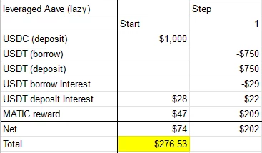

**Pros:**

- Easier to implement than the recursive strategy

- Higher yields than the simple strategy

**Cons:**

- Yield could be higher

- Minor currency risk since USDC and USDT can diverge in price, however, they're stablecoins so this is not likely

## Aave & Curve - 49.7%

[Curve](https://polygon.curve.fi/) also got [incentive rewards from polygon](https://blog.polygon.technology/continuing-scalability-defi-summer-with-5-million-usd-in-liquidity-mining-rewards-from-polygon-e73a76c5a8ad). They've only implemented their infamous 3-pool (a pool that consists of USDC/USDT/DAI) currently and the rates are pretty good

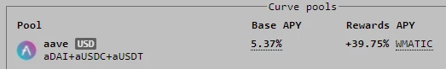

If we take the USDT from previous optimized simple lending (since it can't be used as collateral on Aave) and put it into curve, we would get something like this:

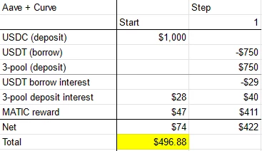

For just farming stablecoins on Aave and Curve, that's a pretty crazy return to be getting almost 50%. To get the MATIC rewards, make sure you stake your curve tokens.

Previously, when you deposit + borrow from Aave, you can be sure that the difference between interest rates is 1-2% (so in terms of risk, you won't be losing too much when borrow interest rates spike up). By borrowing USDT and depositing USDC and 3-pool, you could get into a situation where USDT borrow interest is super high and interest from USDC and 3-pool is lower and so you'd be negative on the stablecoin rewards (you'd still be positive if you factor in Matic rewards).

**Pros:**

- Much higher yield

**Cons:**

- Additional platform risk (curve)

- USDT borrow risk

## Curve only - 45.1%

You might think, with the curve percentages so high, why bother with Aave. As you can see below, your returns will be slightly lower without the initial Aave lending.

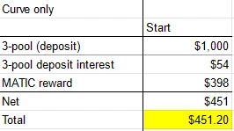

**Pros:**

**- Only one platform**

**Cons:**

- Lower returns

## Aave + Curve + Stakedao - 54%

As I was looking into strategies on polygon, I found a [reddit post](https://www.reddit.com/r/maticnetwork/comments/ncoimw/how_to_get_57_apy_using_nothing_but_stablecoins/) explaining how to get over 50% yield using [stakedao](https://stakedao.org/" \t "_blank). I've never heard of this website before but I'll explain the strategy below.

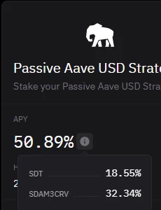

After logging into stakedao, go to 'LP Farming' then click on 'Polygon'. If you deposit your 3-pool tokens with them (instead of staking it on curve in the Aave + curve strategy above), they'll return over 50% APY with the catch that some of the returns are in their own token (SDT) and you get curve tokens (rather than MATIC).

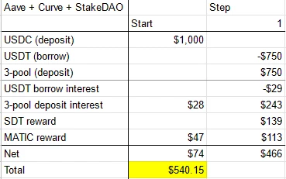

Another advantage of stakedao is that it is auto-compounding, so you don't need to sign in and collect rewards.

**Pros:**

- Highest yield

- Auto-compounds

**Cons:**

- Platform risk (another platform, [low volume token](https://www.coingecko.com/en/coins/stake-dao))

- No matic rewards

## Aave + Curve + Beefy - 52.1%

On the topic of compounding, you'll notice that the Aave polygon rewards are given in APR instead of APY (I think curve might have made a typo). This is because, they do not auto-compound and you need to collect MATIC rewards manually. If you collect once a year, then your return will be the same as the APR listed, however if you collect more frequently and sell the MATIC to buy more USDC (and repeat the strategy) you could get more interest.

Since MATIC looks like it might be going to the moon right now, you might want to collect the MATIC and re-deposit it back into Aave. With additional deposits in Aave, you can use that Matic to borrow more! You can borrow (up to 50%) of deposited MATIC, if you borrow Matic you could do the same recursive leverage strategy listed above and make even more. If I'm lazy, [Beefy](https://polygon.beefy.finance/) has implemented this recursive lending strategy for Matic on Aave and will give you the same returns ([minus 4.5% of rewards](https://twitter.com/beefyfinance/status/1390286217804189700/photo/1)) so you can just keep collecting MATIC from Aave and Curve and deposit into beefy.

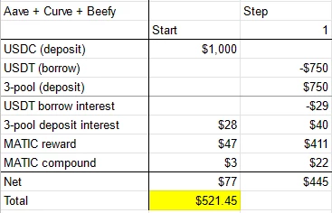

**Pros:**

- Higher yields!

- You get rewards in MATIC

**Cons:**

- Same problems as Aave + Curve

- New platform risk (beefy) or tedious MATIC compounding (make sure you don't press deposit all since you need some left over for transaction fees)

**Happy farming!**